
Data Analyst to Scientist Accelerator

Introduction to Python
SME Peer Review Notes - by Mohamad Hindi

Here are my suggestions/recommendations after reviewing the notebooks. Note that my comments are based on my assumption that the notebook can be used as a reading material to revise not only code but also concepts.

M01_learner_code_along.ipynb

Variables and strings:
- Add notes of why we need variables. Ex: “store data so it can be reused throughout the program”

Basic Functions:
- Add notes of why we create functions.

Conditionals and Truthiness:
- Should we remove this block as there is a whole section about “assert”:

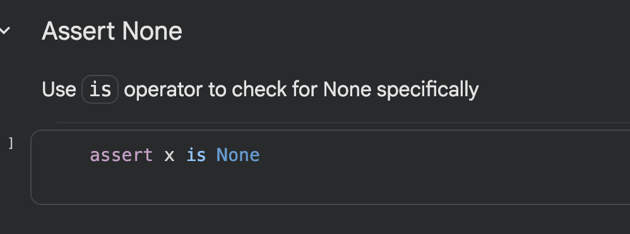

Lists:
- Explain that different data types ( like lists) have different methods you can apply into them. Ex “Each data type comes with a toolkit full of tools you can use, and to access these tools you use “.” followed by the tool name you want to apply”
- Illustrate the difference between a function and a method
- In the dictionary section, you started by creating an empty dictionary in two different ways. To be consistent, maybe we can show how to create an empty list too?
- In this section:
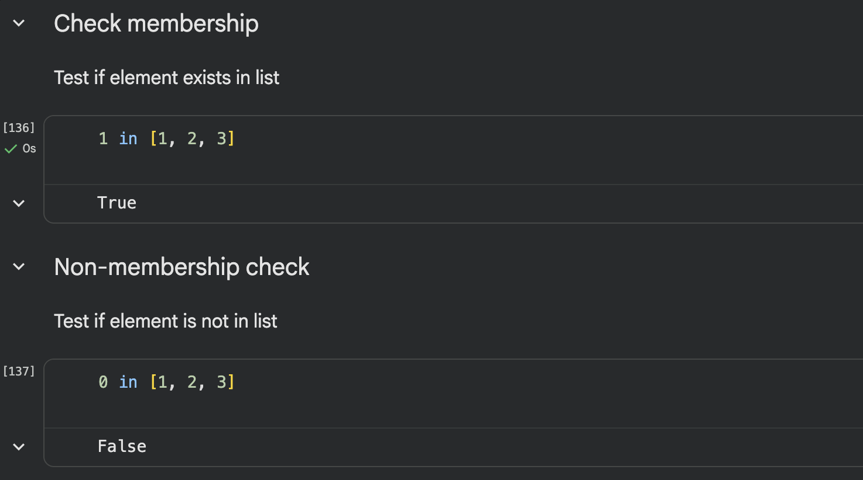

Do we need two subtitles? I mean we are checking for membership, so the element is either present or not.

- In this code:
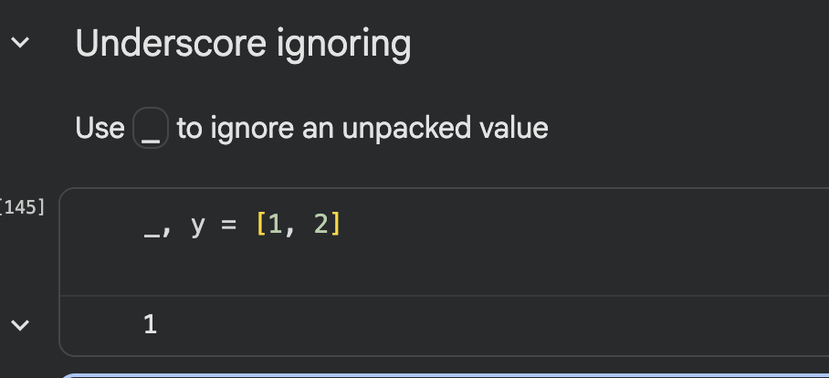

You can still use “_” as a variable and print it out, so not sure if title fits here

- In this code:

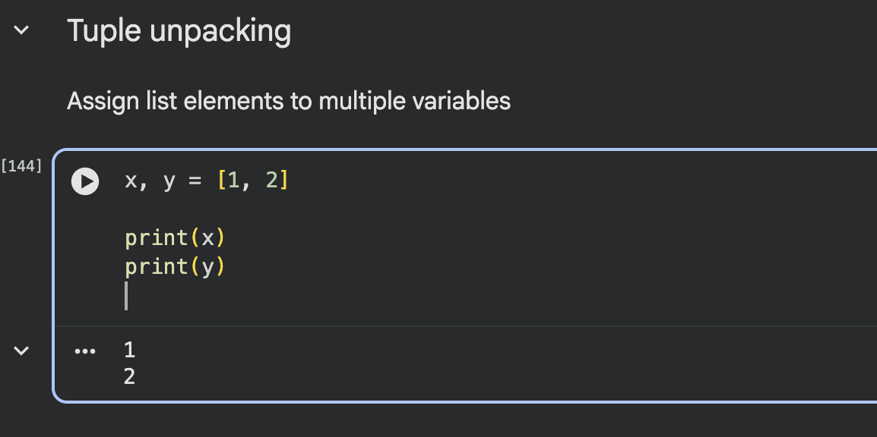

Does the title fit the context? Shouldn't it be “List unpacking” ?

Tuples:
- In these code blocks:
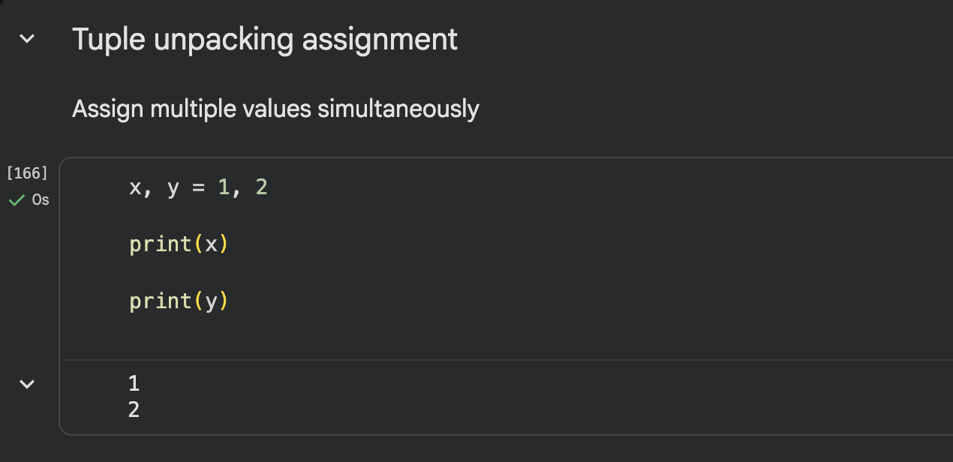

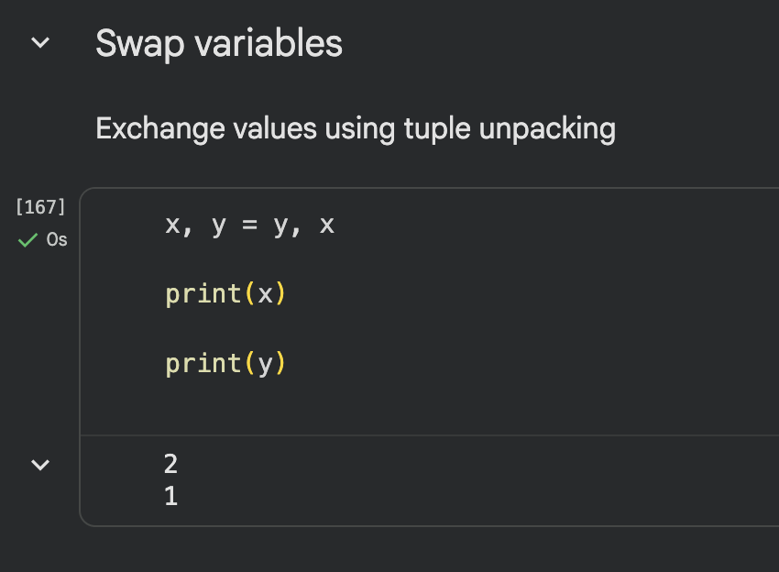

Shouldn’t these be part of the “Variables” section?

Dictionaries:
- In this code:
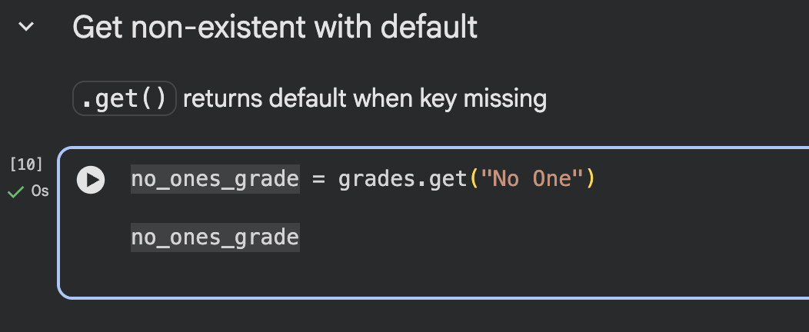

We are not returning any default value, maybe we remove this part or make its purpose more clear?

- Maybe add a section showing how to iterate and print all items in a dictionary?

Sorting:
- In this section:

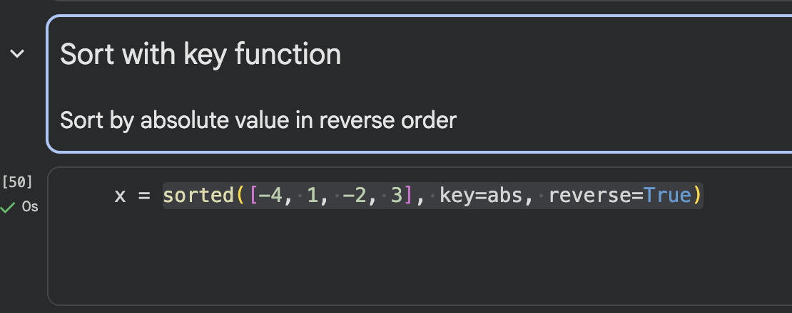

It will be useful to add an example of sorting a dictionary and make use of the key parameter to specify whether to sort the dictionary by key or value

List Comprehension:
- In this block, maybe we switch the order ( so learners grasp the idea of list comprehension with an easier example)
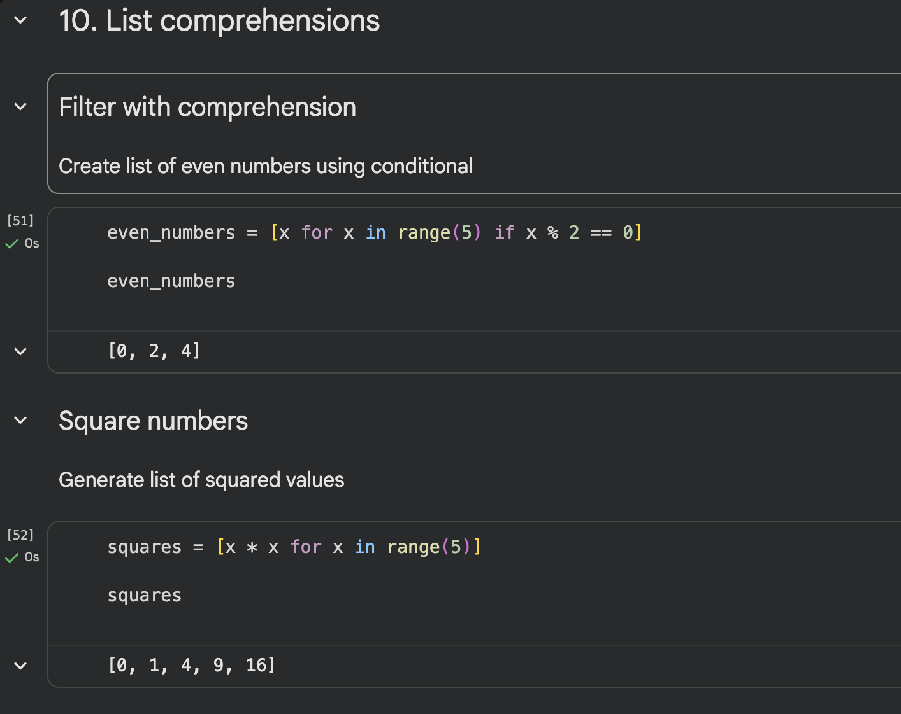

Assertions:
- The purpose of this section is not clear:

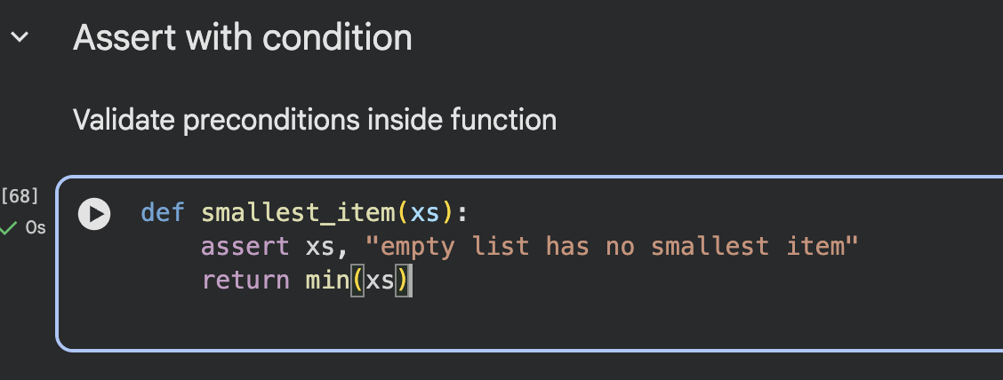

Functions as a value:
- In these blocks:

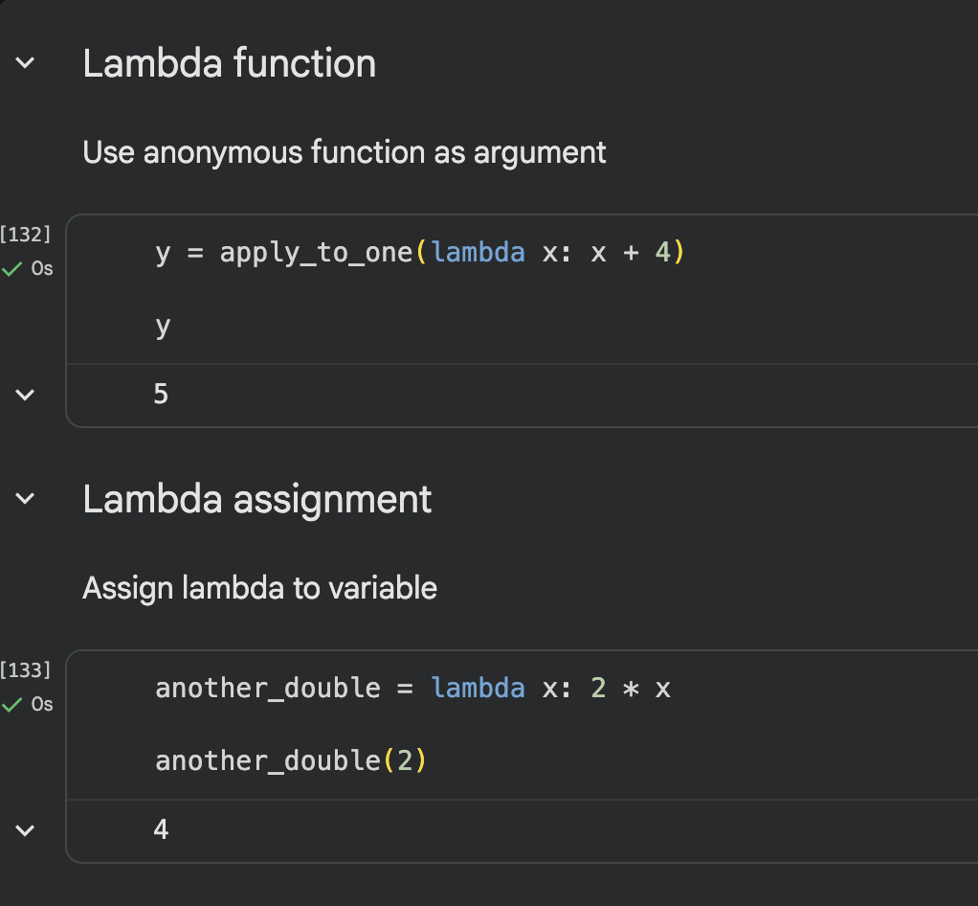
Maybe switch the order so you first explain how lambda works, then use it as a parameter to another function?

- Isnt this block redundant?

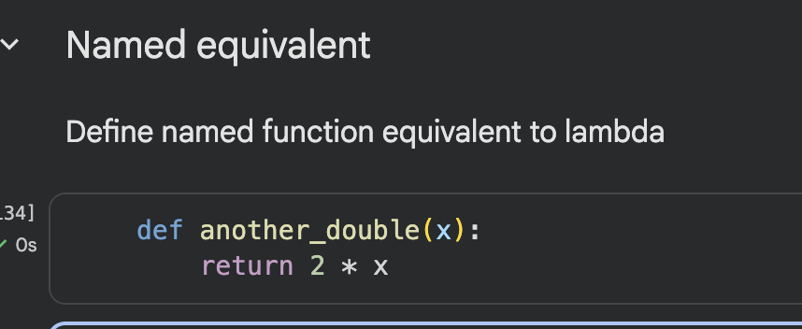

Counting patterns with dictionaries
- Variable `document` not defined

defaultdict and Counter
- Variable `document` not defined
- Maybe clarify more the purpose and context of each cell, showing how to use the output in real scenarios?

Higher-order functions:
- Already mentioned in the general notes, but this section will benefit the most from adding a general syntax, comments, and concept purpose

Regular expressions:
- Already mentioned in the general notes, but this section will benefit the most from adding a general syntax, comments, and concept purpose

General:
- Print out the variables in the same cell they were created
- Add code comments
- Maybe add a section to go over build in functions ( type(), print(), str()). This could be added either before or after the variables section
- Add a short conclusion/interpretation for the notebook subsections. Example:

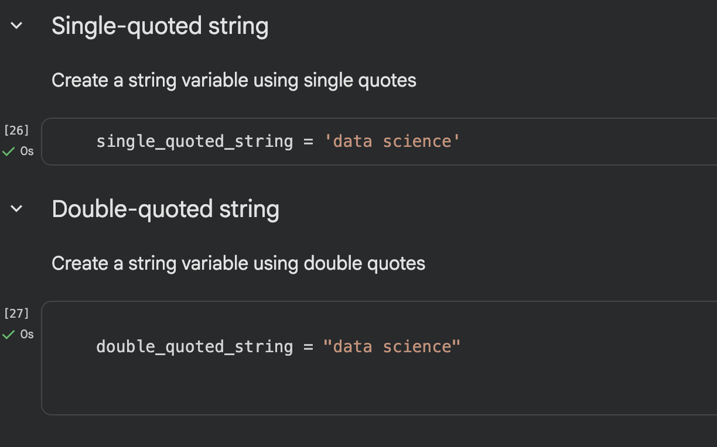

Here we can mention that “unlike other programming languages, python doesn't differentiate between single or double quotation” , “Quotatios are used to differentiate between variable names and text value”

Another example is to point out why you might need to copy a whole list:

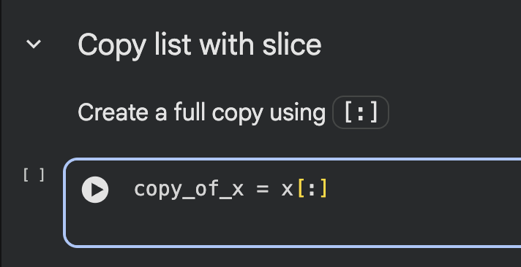

- Add general syntaxes whenever is appropriate. Below are some examples:

For “for loop”
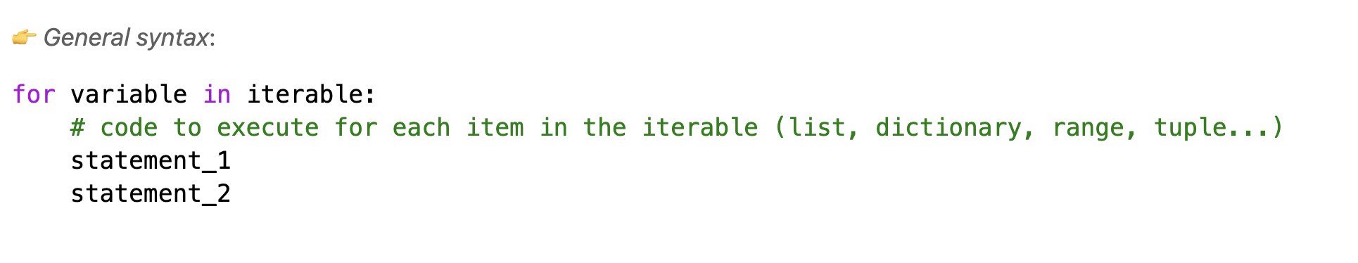
For “slicing”
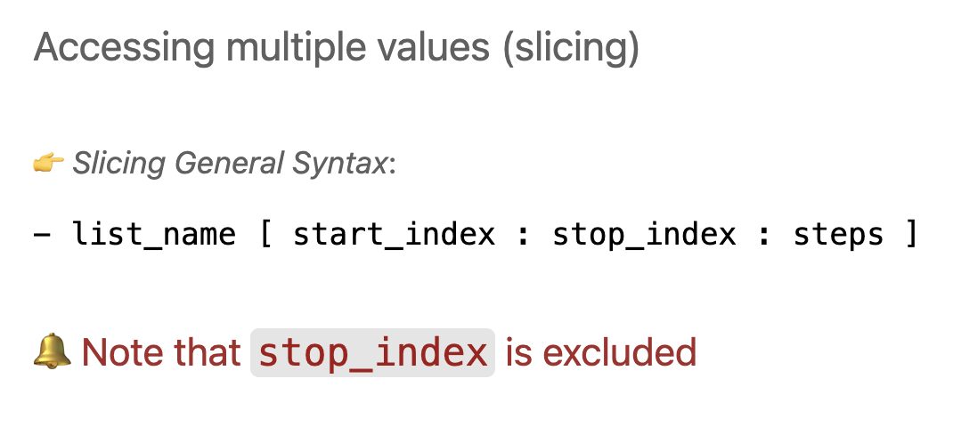
- For each datatype, define what it is and show real scenarios of data needed to be stored as list/dictionary/tuples… Example:

